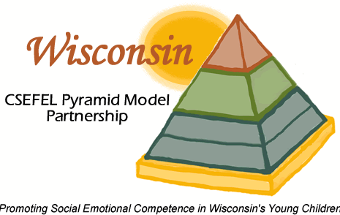
Wisconsin Pyramid Model State Leadership Team
The Pyramid Model state leadership team is a cross-disciplinary team of professionals serves as an advisory committee to oversee Pyramid Model implementation in the state. In addition to the state leadership team, 4 workgroups have been formed to tackle specific tasks.
The workgroups are:
- Data
To organize & evaluate information on the Pyramid Model effectiveness
Contact Lana Nenide at: lnenide@wiaimh.org
- Training support
To ensure coordination and consistency among training efforts related
to the Pyramid Model
Contact Julie Betchkal at: julieb@cesa11.k12.wi.us
- Sustainability/Infrastructure
To ensure sustainability of the Pyramid Model initiative
Contact Lilly Irvin-Vitela at: lilly@supportingfamiliestogether.org
- Information sharing
To disseminate information on the Pyramid Model Initiative
Contact Andrea Murray at: amurray@wecanaeyc.org

